Final Project Report
Christer Hoeflinger Ian Miller
ECE 425
5/8/2017

Intro

Appendix

Simulations:
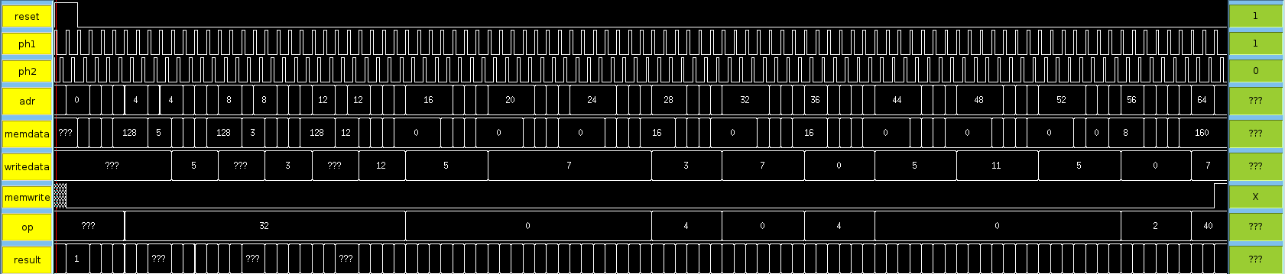Figure 1: Full Chip Test
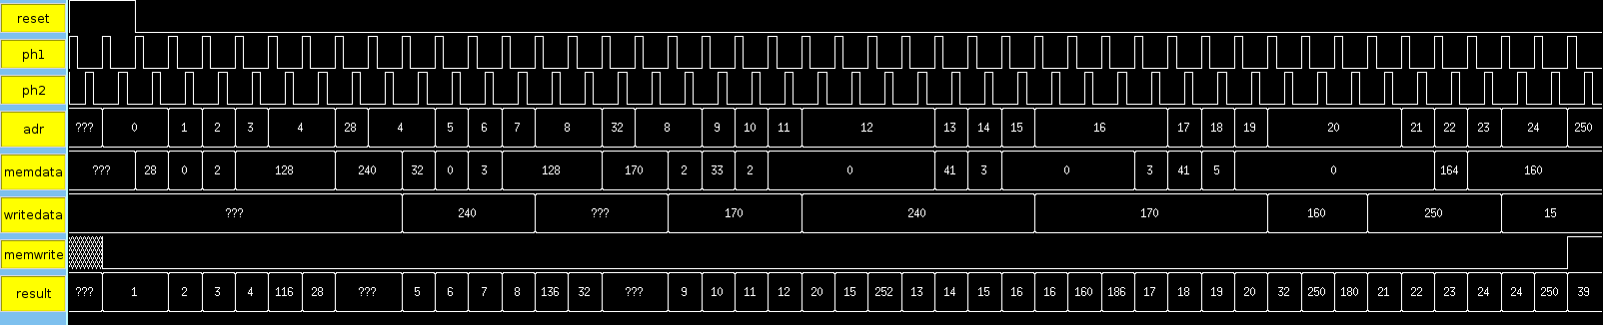Figure 2: Full Chip Test Shifting
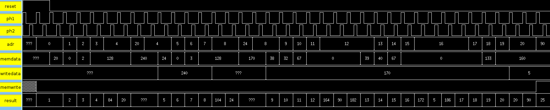Figure 3: Full Chip Test XOR_NOR

